How to track the impact of career-related learning
  - A guide for primary teachers and leaders

What is this resource?
This resource is for primary teachers and leaders. It provides guidance on how primary schools can measure the impact of their career-related learning (CRL).
Just like assessing any form of teaching, measuring the impact of CRL activities is important so that you can:
- Understand whether you are achieving what you set out to achieve
- Identify which parts of career-related learning are working well
- Make effective adjustments to career-related learning

Measuring the impact of CRL activities in this way will help you to have a positive impact on pupils.

Measuring impact

What are you trying to do?
Before you start to measure impact, you should be clear about:

- What are you trying to achieve through CRL? Think about your goal(s). For example, you might want to:
  - Help pupils develop career-relevant skills
  - Broaden pupils’ aspirations
  - Challenge stereotypes about careers
  - Get more parents/employers involved in CRL
  - Improve pupils’ knowledge of the world of work
  - Improve pupils’ knowledge about jobs in their local area

- Who are you targeting? Which people do you want to have an impact on? This might include:
  - Pupils
  - Colleagues
  - Governors
  - Parents/carers

What outcomes do you expect?

Think about what you expect to happen as the result of CRL. You can think about this in terms of outcomes for different levels (individual pupils, classes or year groups) and outcomes for different times (after one activity, or over a longer period of time). The diagram below sets out key questions you could ask to establish these outcomes.

Figure 1: Outcomes for different levels and different times

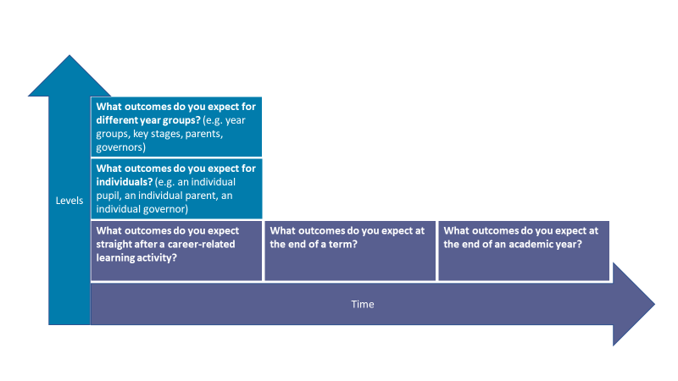
You can find out more about establishing outcomes from these sources:
- NPC: creating your theory of change
- Impact Ed
- Career Development Institute: Careers Framework

Tools for measuring impact
Measuring impact = assessing whether you have achieved what you intended to.

You can use tools to measure your impact against your aims. There is no ‘one size fits all’. The tools you decide to use will depend on what you seek to achieve. The table below sets out tools for measuring impact, how you can use them and who you can use them with.

Tool | How should I use it? | Who can I use this with? | Examples
Surveys | - Survey participants before or at the beginning of your activity, to understand their starting points.  - Conduct your planned activity.  - Survey participants after the activity.  - Look at how responses changed over time.  To construct a robust survey, you should:  - Focus on asking closed-response questions that relate to your goals (e.g. “To what extent do you agree with this statement: ‘science is not for girls’?”)  - Avoid leading questions (e.g. “Why is it important for girls to do jobs that involve science?”). Instead use questions that eliminate bias (e.g. “How do you feel about girls doing jobs that involve science?”)  - Use a balanced set of answer choices, with equal numbers of positive and negative response categories e.g. “strongly agree, agree, neither agree nor disagree, disagree, strongly disagree.” It’s normally best to provide a ‘don’t know’ option, too.  - Don’t ask about two career-related learning activities at once (e.g. “How do you feel about being an astronaut and jobs that involve science?”). Just ask about one thing! | Pupils  Teachers  Parents/ carers  Governors  Employers | The following careers organisations provide guidance for measuring the impact of career-related learning activities and strategies:  - Primary Futures  - Skills Builder
Teacher assessments | You could use assessments and observations that you use during regular lessons to help you understand impact.  For example:  - What do your observations of pupils during CRL tell you about what they are getting from these activities?  - What do your assessments and observations tell you about the skills children are developing over time? You can refer to the Skills Builder framework to help measure this | Pupils | Teacher observation, assessments in related subject areas
School data | You can use existing school data collections to explore the impact of career-related over time. Be aware that changes in wider outcomes (e.g. pupil attendance, behaviour and academic attainment) will not necessarily be because of career-related learning.  To do this, you should:  - Collect data before a CRL activity or whole school strategy starts  - Conduct the activity or whole school strategy  - Collect data in the middle of the activity or whole school strategy (e.g. half way through the academic year)  - Collect data at the end of the activity or whole school strategy (e.g. at the end of an academic year)  - Look at how things have changed over time  You could consider comparing results with pupils from the same class who have not taken part in the CRL activity, in order to get an indication of whether any changes in the data might be due to the CRL activity | Pupils | Attendance records, behaviour points, academic grades in relevant subjects
Existing frameworks | Some organisations have created frameworks and tools, which you could use to help measure the impact of CRL:  - The Careers and Enterprise Company have created 6 evidence-based principles for effective CRL. You can track how far you have achieved the 6 principles as part of your impact measurement  - Skills Builder have created some tools for measuring impact | Pupils  Teachers  Parents/ carers  Governors | Careers and Enterprise Company 6 principles:  https://www.careersandenterprise.co.uk/schools-colleges/primary-school-toolkit/what-careers-related-learning  Skills Builder: https://www.skillsbuilder.org/framework

