Primary Futures: Hallmarks of success for best practice career related learning in primary school and how to achieve them
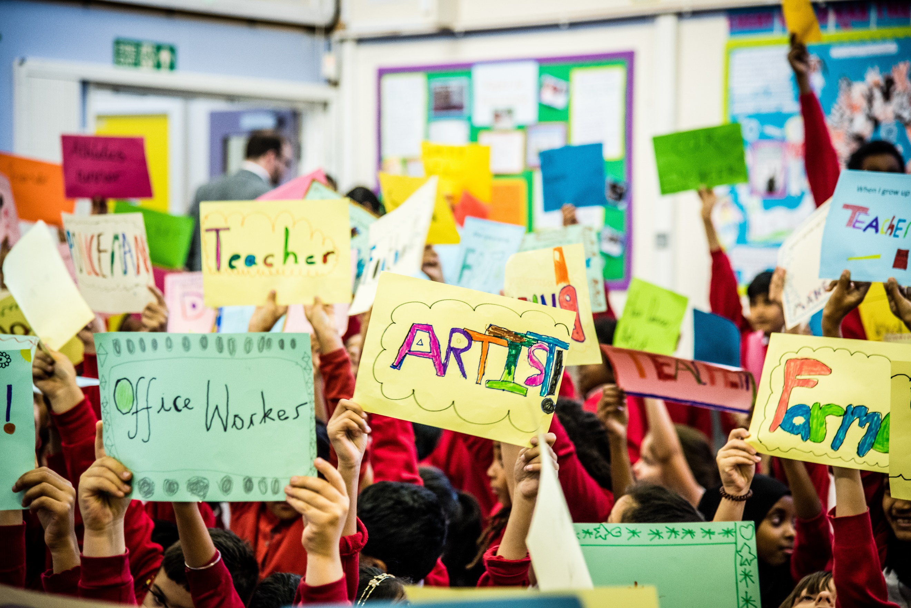
Primary Futures has visited and worked with a large number of primary schools across the UK and further afield and seen first-hand the different ways in which they deliver career-related learning. This teacher resource outlines the ‘hallmarks of success’, endorsed by the NAHT and activity ideas to help achieve these hallmarks. These ‘hallmarks of success’ outline the outcomes that primary schools should aim for and provide when delivering career-related learning:
- Excite and motivate children about their learning by linking and embedding in the curriculum strong connections between education and the world of work
- Broaden children’s horizons and raise aspiration
- Help children see a clear link and purpose between their learning experiences and their future
- Challenge stereotypes that children and their parents often have about jobs and the people who do them
- Support the raising of standards of achievement and attainment for all children
- Help children learn more about their own talents and abilities and instil greater confidence
- Reinforce the importance of numeracy and literacy in later life
- Tailor career-related learning to the different ages and needs of all children
To help support and inspire teachers and schools about how they can target these different outcome areas, Primary Futures has created the following two suggested activity ideas with Primary Futures volunteers to get you started. This resource is a starting guide and Primary Futures has detailed guides to help you with every step of planning the activities. Primary Futures is teacher led so whilst these are activity guides, we support teachers to innovate and adapt them to the particular needs and aims of their school. To use Primary Futures to plan your activities, register for free at www.primaryfutures.org or contact the Primary Futures team at enquiries@inspiringthefuture.org / 020 7566 4880:
Top tips to help with your activity planning
- Always have your intended outcome in mind when planning activities
- Think about the curriculum topics or themed days that you can utilise to bring in volunteers from the world of work.
- Consider the diversity of the volunteers that you invite in – ensure they are not just from only a few sectors or job roles that children might already know about. Every job can be exciting!
- Create a plan for career related learning that covers all school years and ensure you have all staff buy in. Lots of Primary Futures schools have told us it can be helpful to talk about plans in a staff meeting so all staff are aware of the work that is going on.
- Collect feedback after activities from children and volunteers. Remember, Primary Futures can provide free impact assessment packs for schools and tailored post event feedback reports.
- Keep it fun! Primary Futures volunteers are encouraged to bring in props to bring their jobs to life.

Activity Idea 1: What’s My Line Assembly

This activity plan provides ideas on how to address the following outcomes:
- Broaden children’s horizons and raise aspiration: This activity will enable children to learn about a range of jobs in a fun and interactive way.
- Challenge stereotypes that children and their parents often have about jobs and the people who do them: This activity will help to challenge stereotypes as children will meet real people in a range of jobs and they will see that men and women can work in any job.
- Help children see a clear link and purpose between their learning experiences and their future
Remember, Primary Futures can provide free impact assessment packs for schools to help you assess whether these outcomes have been met and the impact that has been made.
Parker’s Church of England Primary School in Norfolk
The school planned an Aspirations Afternoon for their key stage 2 children, involving a ‘What’s My Line?’ Assembly. Seven volunteers attended, from diverse roles such as Defence Specialist, Marketing Expert, and Payment Products Manager. Children tried to guess the jobs of the volunteers during a fun assembly- afterwards the school heard back from parents who commented that the children had come home talking about the volunteers! The children were all asked to write a thank you letter to the volunteer who had inspired them the most, which was a nice way to show the volunteers how valuable their visit had been and enabled the children to reflect on the activity.

Target Audience:
This activity is suitable for all year groups and typically primary schools will run this as a whole school assembly.

Before the activity:
Using the Primary Futures ’Drawing the Future’ template, children can take part in ’Drawing the Future’. This is a fun activity where children draw a picture of what they want to be when they grow up. This can help to get children thinking about their aspirations, reveal potentially held stereotypes which can be explored through discussion and can also be a fun thing to show to volunteers at your event to start conversations. This can support with the Creativity and Aiming High essential skills from the Skills Builder Framework.
Take the activity further:
The children could present their drawings in small groups or to the rest of the class, helping with the development of the Presentation and Listening essential skills from the Skills Builder Framework.
On the day, you could hold a non-uniform day where children dress up as the job they want to be. This can be a fun way to get conversations started at home and raise parental awareness of what you are doing!

The activity:
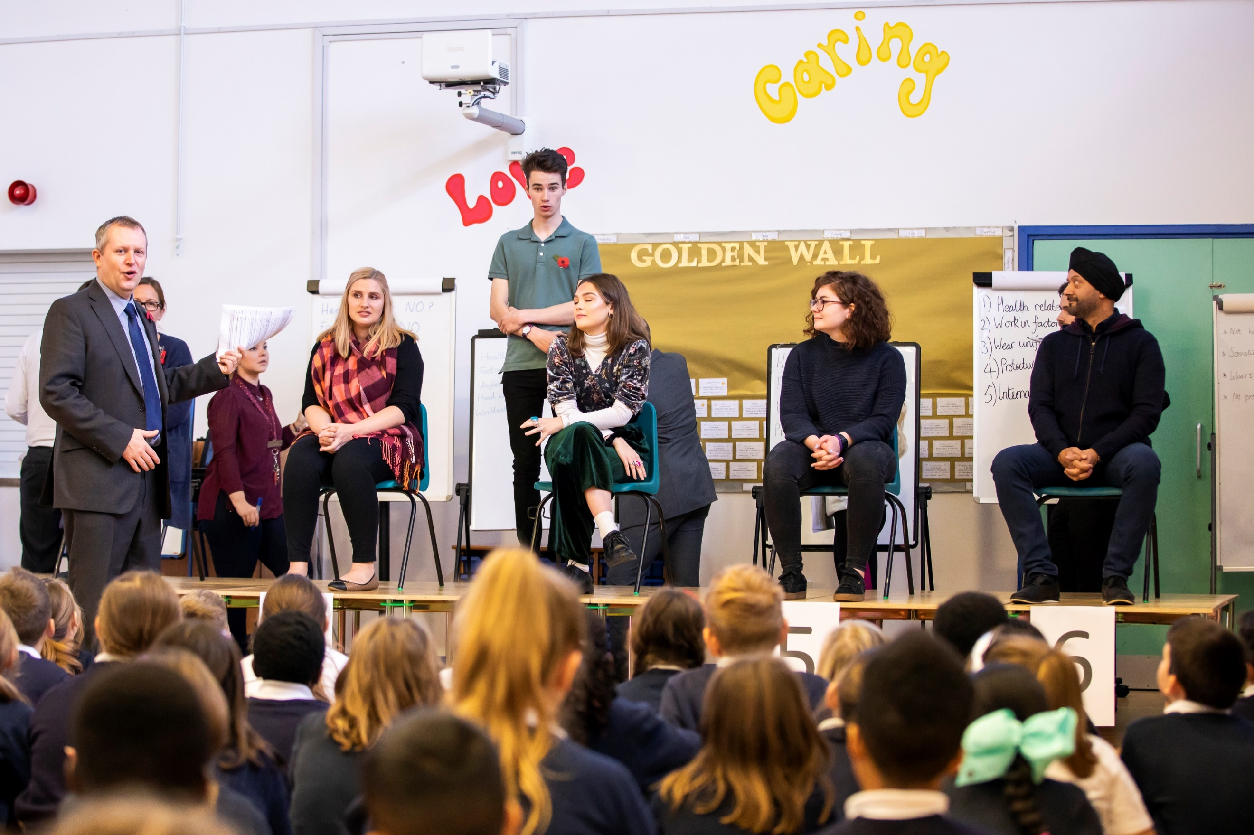
A What’s My Line Assembly typically takes 30 minutes to deliver. Children ask yes or no questions to try to guess the jobs of between 4-6 volunteers from the world of work, in a game show format. Volunteers then reveal their jobs, bringing in props or uniforms to show what they do. Using Primary Futures, invite in a broad range of volunteers from different jobs and sectors. Lots of schools run this activity as their first activity with volunteers from the world of work, as it is quick to organise, fun to take part in and makes a big impact with only a small number of volunteers needed. A detailed step by step guide to planning and running this activity, along with resources to help you with contacting volunteers, is available for free on the Primary Futures portal. These resources include:
- How to use the system and invite volunteers
- Briefing notes for volunteer to engage in the activity
- Question prompts for children
- How to introduce and host the activity tips
- Tips for props for the volunteers
- Further case studies including videos of other schools running this.

After the activity:
Think about how you could embed follow on career related learning activities in lessons post event. These reflection activities can further help support outcomes including Outcome 1 (Excite and motivate children about their learning by linking and embedding in the curriculum strong connections between education and the world of work) and Outcome 3 (helping children to see a clear link and purpose between their learning experiences and their future)
For example:
- In an English lesson, children could write thankyou letters to volunteers – in the letters you could ask them to write about their favourite new thing they learnt about the volunteers they met, to help embed what they heard about. This can support with the Creativity and Listening essential skills from the Skills Builder Framework.
- In a maths lesson, children could be asked to solve a problem that one of the volunteer jobs might do. For example, they could be asked to work out the time it would take for a taxi driver to travel to an address 5 miles away if travelling at 20 miles an hour. This can support with the Problem Solving essential skills from the Skills Builder Framework.
- You could involve the volunteers that have visited your school in planning for this. For example, ask them to suggest some maths challenges they face day to day and then adapting them to the year group you are working with.

Activity Idea 2: Speed Networking Classroom talks

This activity helps to address the following outcomes:
- Excite and motivate children about their learning by linking and embedding in the curriculum strong connections between education and the world of work: In a fun and interactive activity, volunteers will talk about the subjects they use in their jobs.
- Broaden children’s horizons and raise aspiration: Children will meet a range of volunteers in different roles.
- Help children see a clear link and purpose between their learning experiences and their future: By talking about how they use different subjects in their jobs, volunteers will help bring learning to life.
- Challenge stereotypes that children and their parents often have about jobs and the people who do them: By meeting real life people, vehicle will learn about the range of people that can do different jobs.
- Help children learn more about their own talents and abilities and instil greater confidence: Children can ask questions and develop their skills including 3 of the Eight Essential Skills – listening, aiming high and presenting. By talking to volunteers and hearing about their job stories, children can reflect on their own abilities.
- Reinforce the importance of numeracy and literacy in later life: Volunteers talk about how they use numeracy and literacy in the working world.
Kingswood Primary Academy in Corby
Kingswood Primary Academy invited a number of volunteers in via Primary Futures, including a male nurse and female police officer. Before the activity they asked Year 3 children to draw pictures of people in 7 different jobs and give the drawings names. Only 9 drawings of the Nurse were of men, compared to 18 of women and for the Police Officer only 5 were women compared to 22 men. The volunteers then came into the classrooms and revealed their jobs. They then chatted to the children about their roles and showed props to bring their jobs to life.
Remember, Primary Futures can provide free impact assessment packs for schools to help you assess whether these outcomes have been met and the impact that has been made

Target Audience:
This activity is suitable for all year groups but typically primary schools will run this for Year 4 to Year 6 children, who will be more able to ask questions and chat to the volunteers. If you would like to run this with younger age groups, consider preparing the children with some background information about the volunteers.

Before the activity
Ask the children to draw some of the jobs that are coming along to the event to get them thinking about what they understand or believe about what the job may involve. After the session, you could repeat this activity to see if there are any changes in views on what those jobs look like. This can help with Outcome 4, revealing stereotypes that may be held and which can then be explored through discussion. This can support with the Creativity and Presenting essential skills from the Skills Builder Framework. Have a look at our Redraw the Balance video for inspiration https://www.youtube.com/watch?v=kJP1zPOfq_0

At the start of the year, ask subject leaders to identify a few curriculum or topic based opportunities to use volunteers from the world of work. Make sure you give volunteers some background to what the children have been learning, so they can mention that in their talks.

The activity:
This activity typically needs between 1-2 hours to deliver, though it can take longer or shorter depending on the number of volunteers you want to invite in. Lots of Primary Futures schools run this following a What’s My Line assembly, so that volunteers can then speak to children in more detail about their roles. Typically, volunteers will bring in props and spend 15 minutes chatting to small groups of children about what they do in their jobs and the subjects they use in their roles. Volunteers will then rotate to the next group or class, enabling children to meet a wide range of volunteers across the event. This activity can support with the Presenting and Listening essential skills from the Skills Builder Framework. A detailed step by step guide to planning and running this activity, along with resources to help you with contacting volunteers, is available for free on the Primary Futures portal. These resources include:
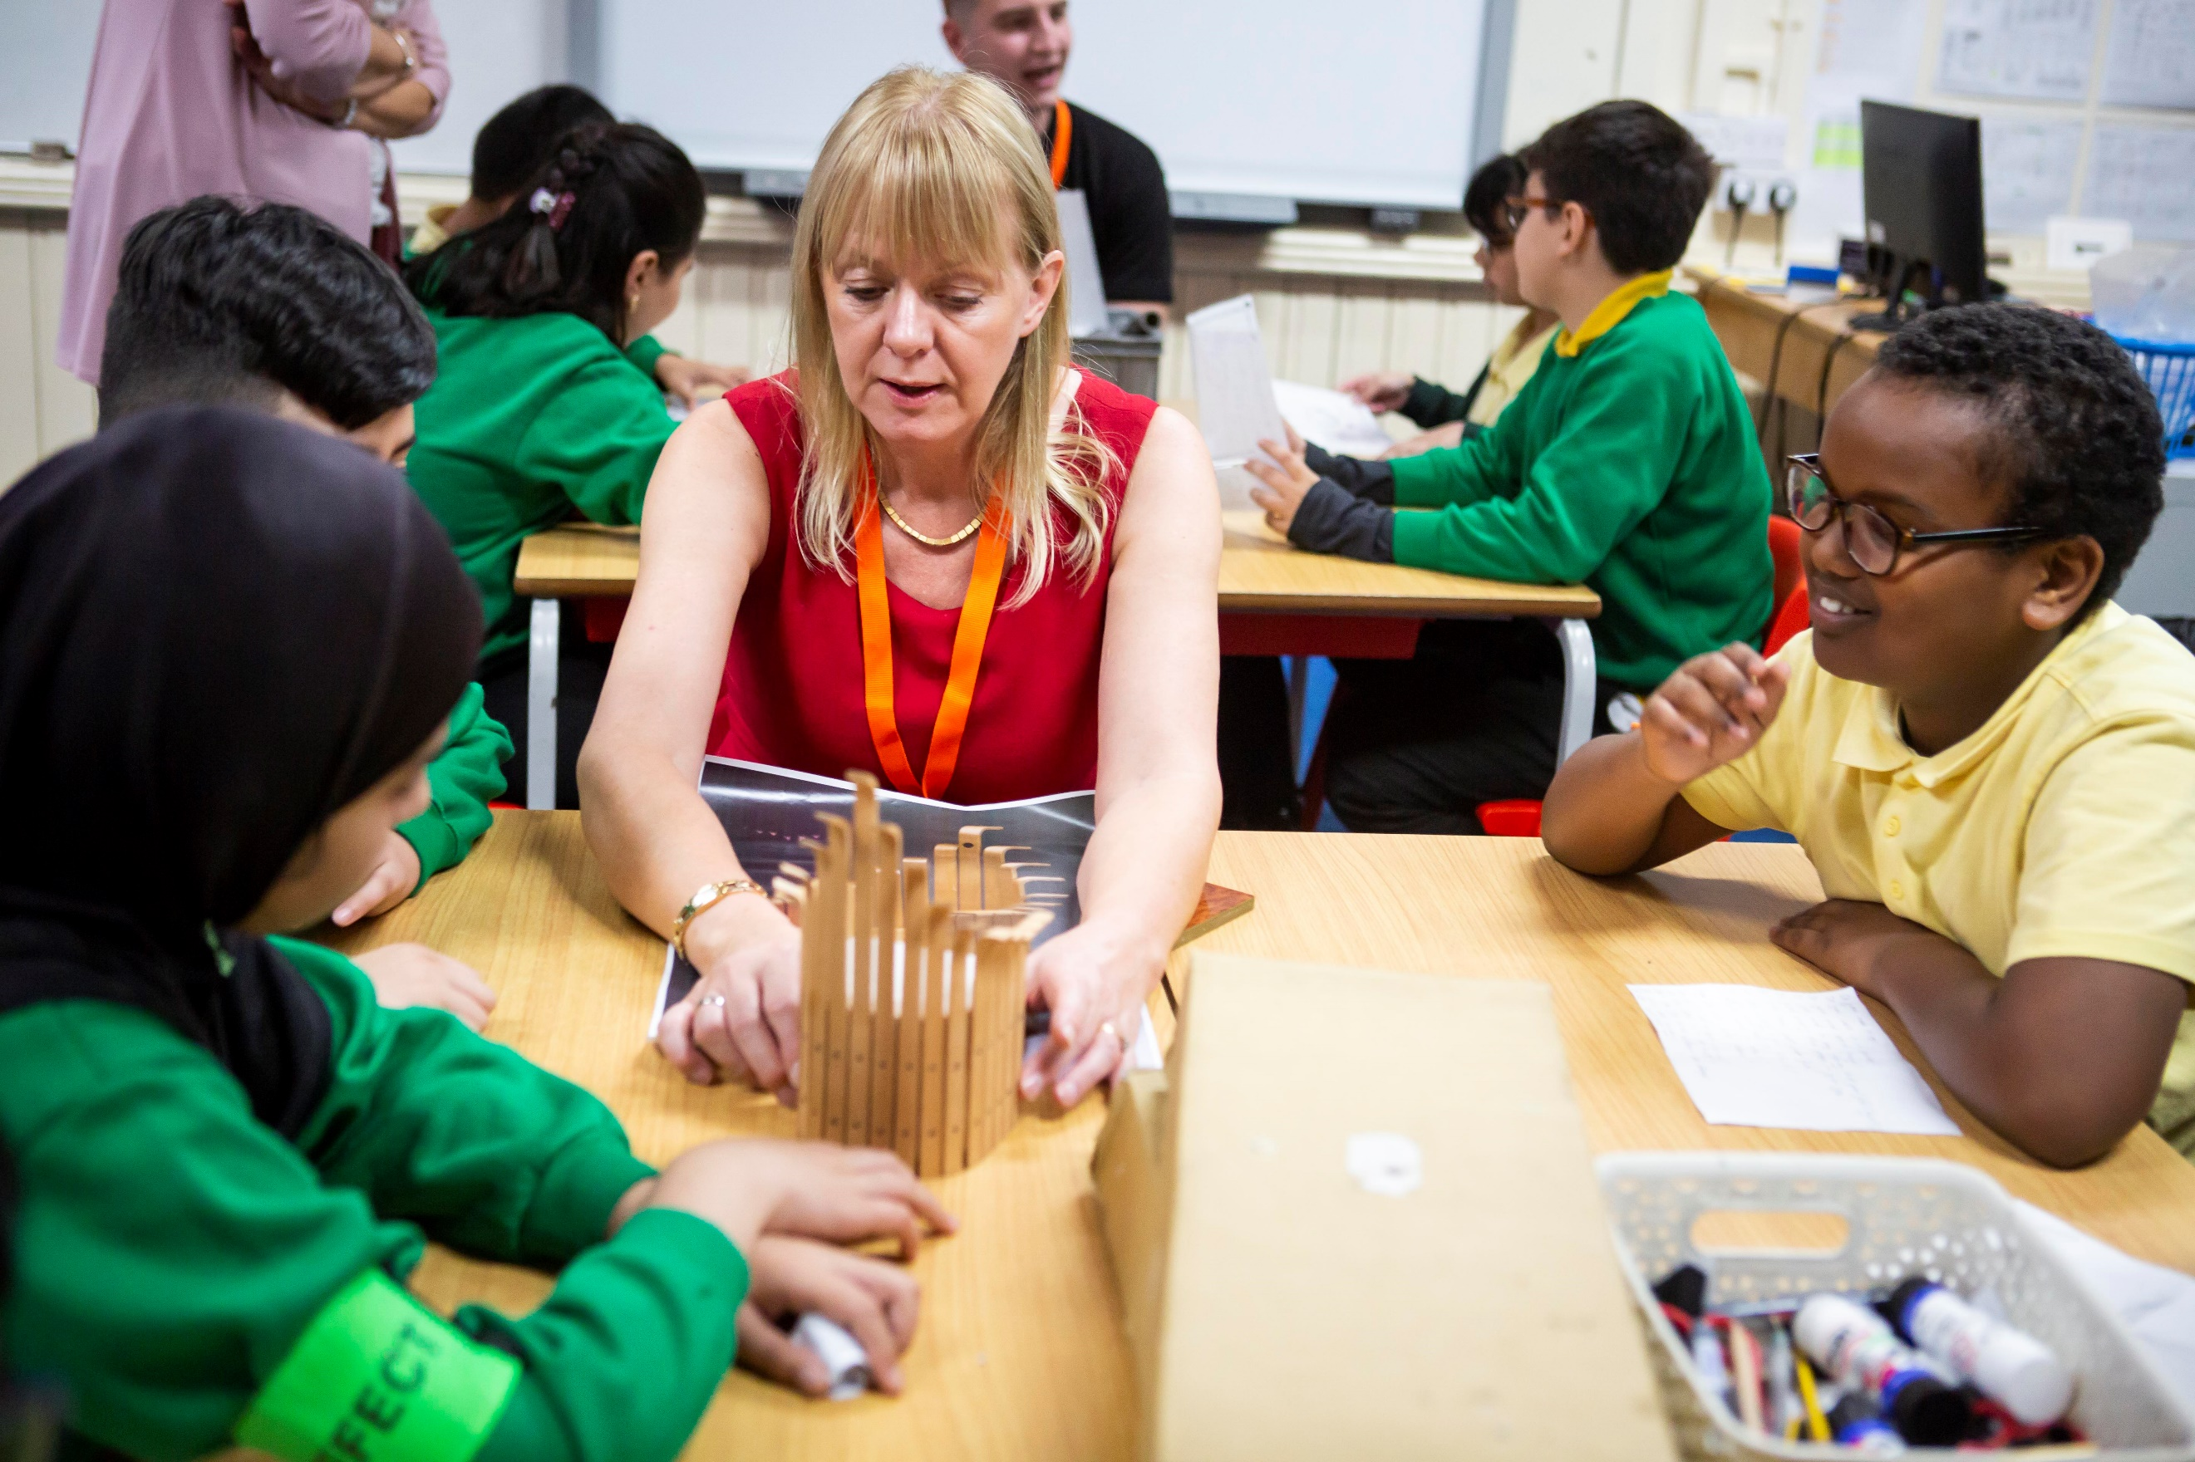
- How to use the system and invite volunteers
- Briefing notes for volunteer to engage in the activity
- Question prompts for children
- How to introduce and host the activity tips
- Tips for props for the volunteers
- Further case studies including videos of other schools running this.

After the activity:
- Make sure that time is built in to enable children to reflect on what they have heard and learnt. Continue to reflect and refer to the visits from volunteers in lessons, so that children understand the wider importance of what they are learning and the need to aim high.
- After the session, you could repeat the drawing activity to see if there are any changes in views on what those jobs look like. Encourage the children to take the drawings home and talk to parents or carers about them to embed learnings.
- Ask the children to complete a feedback form where they can self-assess what they have learnt- this can be referred to when planning your next activities to ensure they continue to be targeted and outcome driven. Remember, Primary Futures can provide free impact assessment packs for schools and tailored post event feedback reports.

