Please add to your person: hair, eyes, skin colour, work clothes and a name.
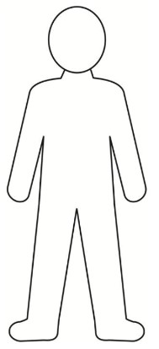
Can you tell us about the person in the box below?
_________________________________________________________________________

_________________________________________________________________________

_________________________________________________________________________

_________________________________________________________________________

_________________________________________________________________________

_________________________________________________________________________

_________________________________________________________________________

_________________________________________________________________________

_________________________________________________________________________

_________________________________________________________________________
_________________________________________________________________________

Pupil Voice
Teacher Notes
_________________________________________________________________________

_________________________________________________________________________

_________________________________________________________________________

_________________________________________________________________________

_________________________________________________________________________

_________________________________________________________________________

_________________________________________________________________________

_________________________________________________________________________

_________________________________________________________________________

_________________________________________________________________________

_________________________________________________________________________

_________________________________________________________________________

