Environmental Sector Job Examples

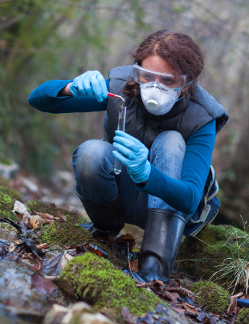
Conservation Scientist A Conservation Scientist is someone who manages the overall land quality of forests, parks, rangelands and other natural resources. They work with people who own the land and the government to make sure the land is looked after properly.

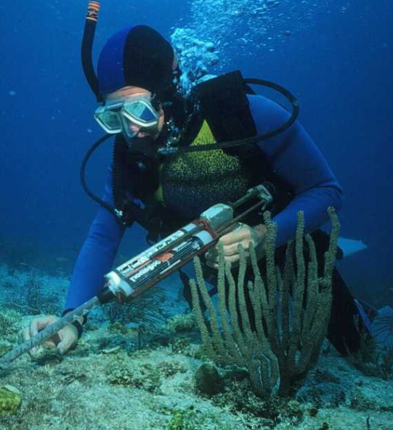
Wildlife Biologist
A Wildlife Biologist is a scientist who studies animals in their natural habitat. They look at what the animal eats and also what eats that animal as well as the impact that humans have on the environment. A Wildlife Biologist will spend a lot of their life exploring different countries to find out as much as possible about different species to educate other people on how to look after all animals.

Environmental Engineer
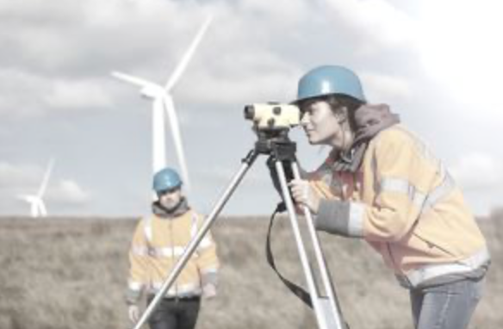
An Environmental Engineer is someone who uses science to help solve environmental problems. They help to improve recycling, waste disposal and control of air pollution.

Food Scientists
A Food Scientist develops eco-friendly food practices that are better for the environment. They help to make sure that farming is sustainable which means that it can keep going and that the food won’t run out. They also help fisheries adapt to climate change as well as discovering new plants that can be eaten.

