Year 1 Lesson 3
Staying Positive and Aiming High
You open your sandwiches and they are ham salad, your least favourite, how do you react?
What would be the best way to react and why?
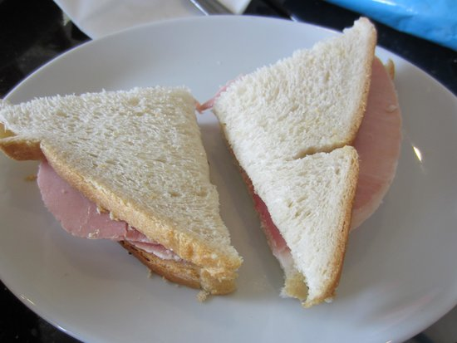

Your team loses a football match and your friend says something unkind, what do you do?
How can you stay positive in this situation?
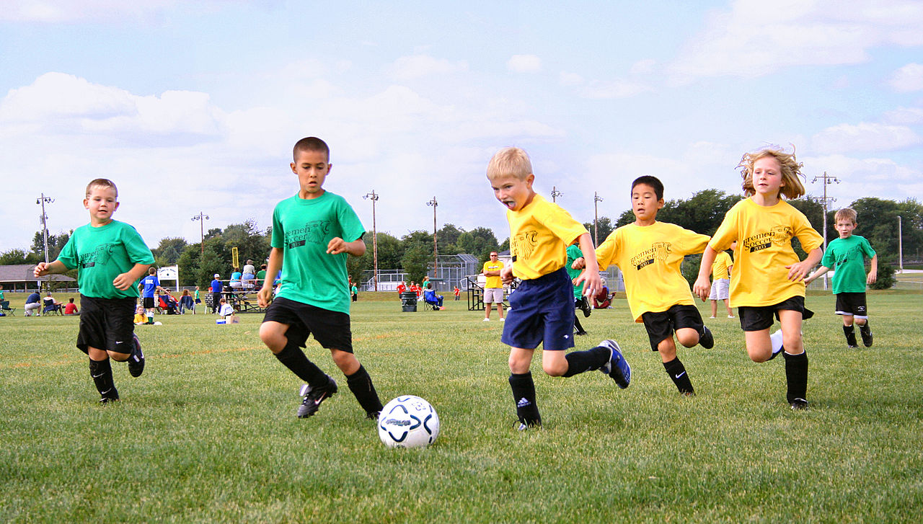

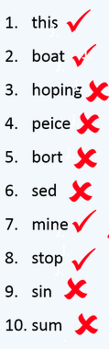
You take a spelling test and feel disappointed with your score, how do you show that you have a growth mindset? If somebody had a fixed mindset, what would their reaction be?

Your friend has a gymnastics performance that he is really nervous about and he keeps saying that he is not good enough. How could you help him to use his growth mindset?

