Careers Hub User Guide – Year 2

Thank you for choosing to use these resources. All the Black Country resources were designed with that local area in mind, but they are all adaptable to your context. For example, you can swap out Black Country Businesses for those relevant to your own area. All the resources for Y2 are also available on the Ryders Hayes School website.

They have been written by a teacher, in discussion with teachers, at Ryders Hayes Primary School and within the Careers Hub, who have refined these documents to ensure that they work to:

- Challenge stereotypes
- Broaden horizons and help children to feel empowered to have multiple options and choices for their future education and careers.
- Help children learn about transferable skills and the type of activities that can help them to develop these
- Help pupils to identify which skills they already possess, and which activities have helped to develop these skills.
- Encourage pupils to aim high and explore a vast range of careers/jobs available to them in 2030.
- Make children aware of the changes in technology in the past ten years and look into what technology could be like in 2030, when they are entering the world of work and the impact this may have upon jobs in 2030.

These lessons have worked as part of our PSHE/Life Skills curriculum and have worked to boost children in the eight essential skills for the world of work: Leadership, Teamwork, Creativity, Problem-Solving, Presenting, Listening, Aiming High and Staying Positive. We have found that our children have become very aware of their own needs and how they can help themselves to improve in these areas through writing Skills Action Plans.
The progressive curriculum spans from Early Years (EYFS) to Year 6:
Pre-learning in EYFS and KS1 includes being introduced to 35 visitors from the world of work who bring in an item/artefact which symbolises the work that they do. Children are then able to ask questions about their line of work and the difference they make to their world. This item/artefact then forms part of the Careers Hub Corner for children to use during their child-initiated learning. The children then progress to assessing their social, economic and cultural capital to develop a self-awareness of strengths and key skills. They experience half-termly workshops which focus on the children understanding what the eight essential skills are and how they can work to develop these whilst still challenging stereotypes.
By the time children reach KS2, they should already have a sound knowledge of what stereotyping means and be developing the 8 essential skills. KS2 lessons are split into sectors with each KS2 year group delving into:
- what a sector actually is and what this means in the world of work,
- an exploration of real-life contexts for the terminology of careers and the world of work, whilst addressing any misconceptions that they may have.
- The Labour Market Index for the Sector in their hometown, and what jobs may be available in 2030 in the real companies that make up the sector.
- Real organisational charts to discover what roles and responsibilities exist within a sector company.
- A contextual film giving the real picture of the world of work within the sector and interviews with employers and employees.
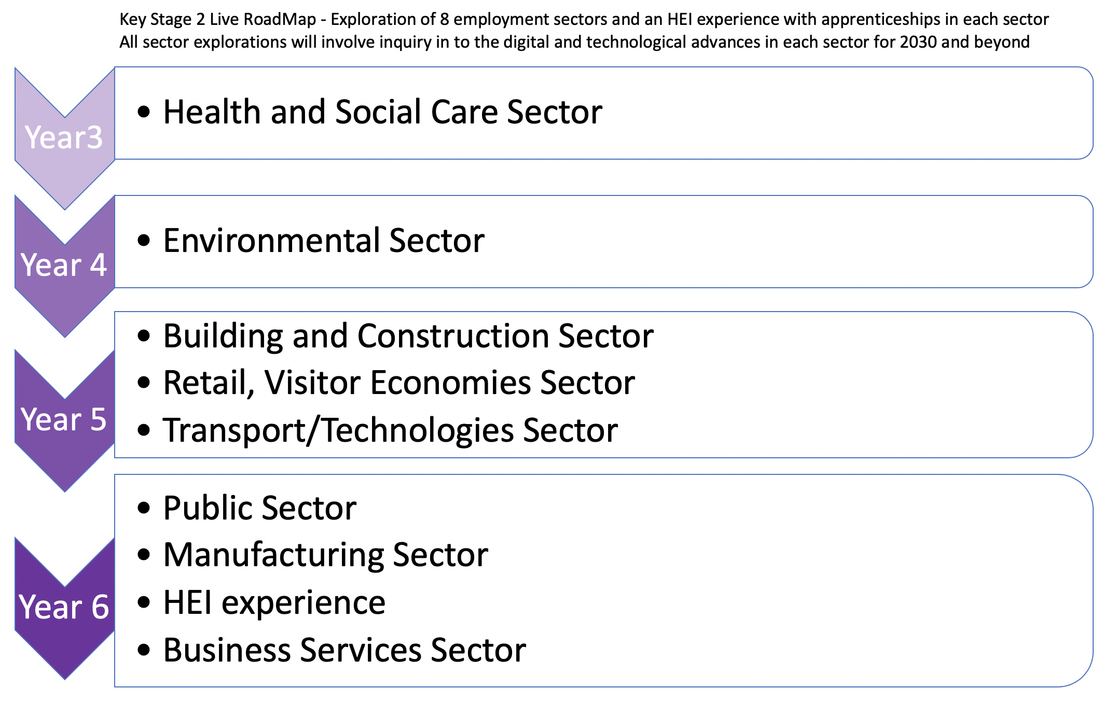
Each Sector represents a ‘bundle’ of work with at least one pre-event and one post-event lesson expected to last around 90 minutes each. These bundles are all available here and include all resources highlighted on the lesson plans.
At Ryders Hayes this year, we have held a ‘live event’ for each sector whereby our children have visited employers in their workplace, or employers have been invited into school to share their jobs/careers with the children and answer pre-prepared questions to assist the children in their learning.
Should your school be unable to invite employers in or visit a workplace, the high-quality video available on the website can be used instead to showcase what each workplace looks like alongside talking to a range of employers about their roles within the business/organisation. This video will help the children to gain an insight into that sector and help them to develop their futuristic company for 2030 as part of their post-event lesson.

To measure the intended impact of the programme, we asked the children, parents and staff to answer questionnaires before and after receiving the curriculum, results of which will be found on our website. The outcomes speak for themselves – this imaginative curriculum, coupled with the exciting range of experiences and taught sessions, have changed children’s perceptions of the world of work and all that it offers (and what they can offer the Black Country) - for good!

What it looks like for Year 2

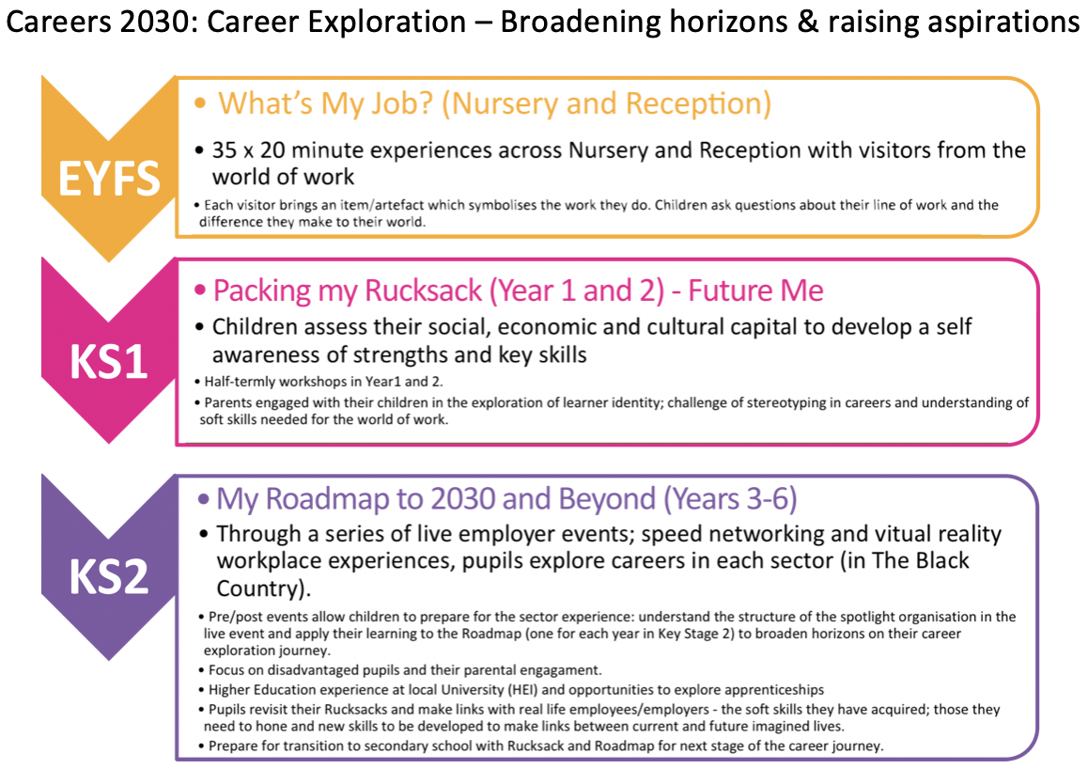
Year 2 delve into the eight essential skills with a lesson every half term lasting around 90 minutes. The essential skills are paired into the following lessons found here:

Lesson one: listening and presenting.
Lesson two: problem-solving and creativity.
Lesson three: aiming high and staying positive.
Lesson four: teamwork and leadership.
Lesson five: the children are set a challenge which helps to build on all of the eight essential skills.
Lesson six: ‘What’s my job?’ assembly where employers from the world of work are invited in to talk to the children. The children have to try and guess their jobs based on stereotypes and will then go into smaller groups to discuss the job/career in more depth dispelling any misconceptions that the children may already have.

Throughout the year, staff use Skills Builder to assess and develop their class. All of the skills are broken down into mini steps that are used to support the children in moving onto the next stage, all in preparation for their KS2 curriculum based on individual development.

These lessons have all been created to embed prior learning in Year 1, children will have already been introduced to the eight essential skills but will begin to make explicit links between the skill name and how they are using these.

