Please add to your person:
hair, eyes, skin colour, work clothes and a name.
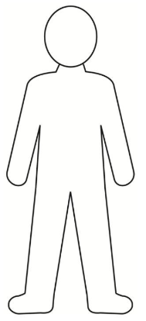

Can you tell us about the person in the box below?
_________________________________________________________________________

_________________________________________________________________________

_________________________________________________________________________

_________________________________________________________________________

_________________________________________________________________________

_________________________________________________________________________

_________________________________________________________________________

_________________________________________________________________________

_________________________________________________________________________

_________________________________________________________________________

Please add to your person:
hair, eyes, skin colour, work clothes and a name.
Can you tell us about the person in the box below?
_________________________________________________________________________

_________________________________________________________________________

_________________________________________________________________________

_________________________________________________________________________

_________________________________________________________________________

_________________________________________________________________________

_________________________________________________________________________

_________________________________________________________________________

_________________________________________________________________________

_________________________________________________________________________

_________________________________________________________________________

Pupil Voice
Teacher Notes
_________________________________________________________________________

_________________________________________________________________________

_________________________________________________________________________

_________________________________________________________________________

_________________________________________________________________________

_________________________________________________________________________

_________________________________________________________________________

_________________________________________________________________________

_________________________________________________________________________

_________________________________________________________________________

_________________________________________________________________________

_________________________________________________________________________

